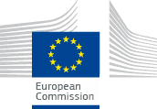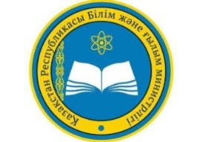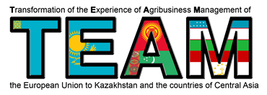
This project has been funded with the support of the European Commission. The contents of this publication/material are the responsibility of the author and do not reflect the views of the European Commission

Roundtable for “Transformation of the experience of agribusiness management of the European Union to Kazakhstan and the countries of Central Asia”

Hosted by Kostanay Engineering and Economics University named after M.Dulatova (KINEU).

Attendees: Participants of the Erasmus project + Jean Monnet module “Transformation of the experience of agribusiness management of the European Union to Kazakhstan and the countries of Central Asia”.

Time and venue: KINEU, 59 Chernushevskogo str, main building, 304 office.
27 декабря 2018 г.

Working languages: Kazakh, Russian, English.

The purpose of the event “Round Table”:
- familiarization with the experience of management in the EU agribusiness and the possibility of its integration in Kazakhstan;
- familiarization with the EU agricultural policy.

PROGRAMME
15.00-15.10 | Opening session of the Round Table  Moderator. Opening speech.  Pritula Raisa - Candidate of Economic Sciences, Ph.D., Corresponding Member of the IAAO (International Academy of Agrarian Education), Professor of the Department of Economics and Management of KINEU.
15.10-15.20 | Galina Ismuratova - Doctor of Economics, Professor, Dean of the Faculty of Distance Learning of KINEU.  Fundamentals of the EU agricultural policy.
15.20-15.30 | Sabit Ismuratov - Doctor of Economics, Academician of the IAAO, Professor, Rector of KINEU.  Agribusiness of the EU and Central Asia in modern geopolitical conditions.
15.30-15.40 | Shayakhmetov Amangeldy - Ph.D. in Engineering Science, Vice-Rector for Research at KINEU.  EU agribusiness management.
15.40-15.50 | Eseyeva Gainiya - Candidate of Agricultural Sciences, associated professor, Head of the Department of Standardization and Food Technologies at KINEU.  EU agribusiness in crop food markets.
15.50-16.00 | Eseyeva Gainiya - Candidate of Agricultural Sciences, associated professor, Head of the Department of Standardization and Food Technologies at KINEU.  EU agribusiness in food markets for livestock products.
16.00-16.10 | Tatyana Ostryanina - Master of Economics, Dean of the Faculty of Economics of KINEU.  Methodological foundations of investment management.
16.10-16.20 | Dyuzelbaeva Gulnara - Candidate of Economic Sciences, Associate Professor, Vice-Rector for Academic Development of KINEU.  Investment management in EU agribusiness and increasing its efficiency.
16.20-16.30 | Sarsembayeva Gulmira - Master of Management in the specialty “Agricultural Management”, Head of the Department of Economics and Management of KINEU.  Management and planning of investment activities.
16.30-16.40 | Pritula Raisa - Candidate of Economic Sciences, Ph.D., Corresponding Member of the IAAO (International Academy of Agrarian Education), Professor of the Department of Economics and Management of KINEU.  Agribusiness and EU environmental policy.
16.40-16.50 | Zhamalova Dinara - Candidate of Agricultural Sciences, Associate Professor, Head of the Department of Scientific Research of KINEU.  Technological innovation and consolidation in the EU agribusiness as the basis for competitiveness.
16.50-17.00 | Zhunusov Kuat - Candidate of Economic Sciences, Associate Professor, Head of the Department of Computer science and Automation of KINEU.  Information systems in EU agribusiness. Digital Farming.
17.00-17.10 | Pritula Raisa - Candidate of Economic Sciences, Ph.D., Corresponding Member of the IAAO (International Academy of Agrarian Education), Professor of the Department of Economics and Management of KINEU.  Prospects for the development of EU agribusiness and cooperation with Central Asian countries.
17.10-17.30 | Discussion and preparation of resolution.

